7.1 - Weather Systems
(keeping it in the Northern Hemisphere)
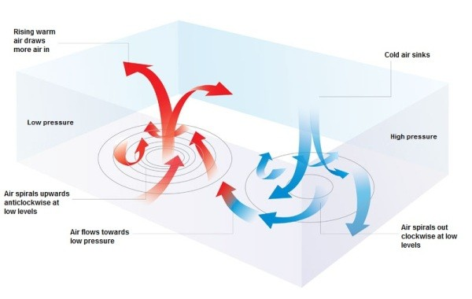

HIGH | Anti-cyclone
LOW | Depression

Air masses

Air mass | Why Warm/Cold | Why Humid/Dry
Warm, dry air
Warm, humid air
Cold, dry air
Cold, humid air

Why is warm, humid air less dense than cold, dry air?
Cold, dry air
Warm, humid air

Typical Depression (Temperate Regions)
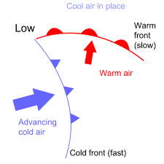
Winds tend to blow at approx 15° to the letf of the isobars. Note the anti-clockwise direction.

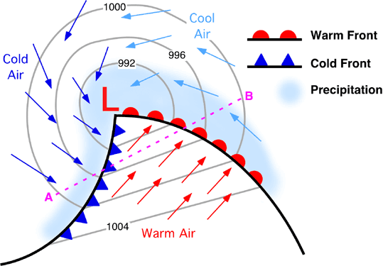
Vertical Cross-section

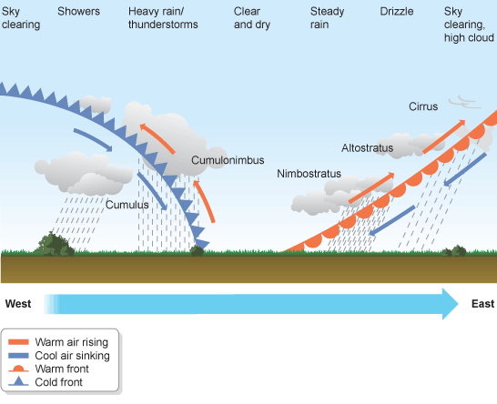

 | Change in air temp | Typical weather
WARM FRONT
COLD FRONT
How do they form?

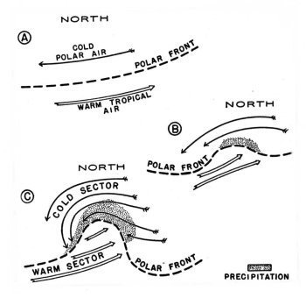

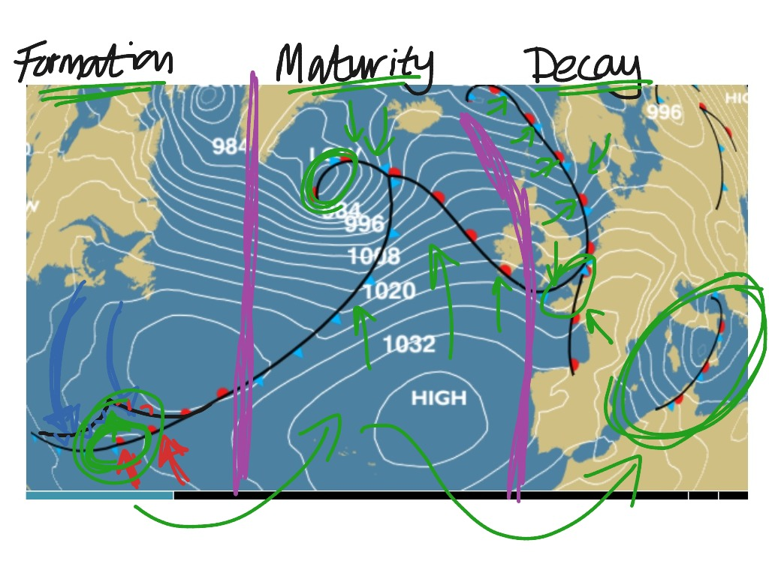
The cold front moves faster than the warm front and eventualy catches it up! This produces an OCCLUDED FRONT – yeuky weather.
