LAB 1 – Buoyancy Name: …………………….…………
Aim: To be able to determine the upthrust of a submerged object and compare with the value predicted by Archimedes’ Principle. The buoyancy force (upthrust) = weight of water displaced.
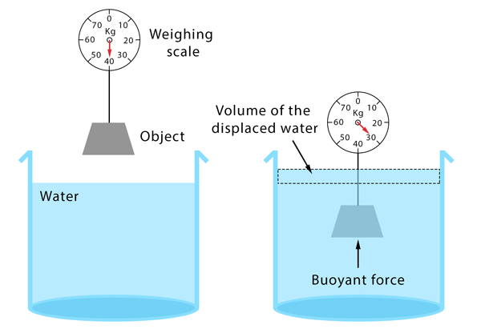
Method (part 1):
- Suspend an object from a newton meter (spring scale) and record the reading.
- Submerge the object in water and again record the newton meter reading.
- Record the volume of the object.
- Repeat for a range of materials.
Data (3 marks)

Sample | Weight, mg  (N) | Volume, V  (cm³) | Density, ρ  (g/cm³) | Measured upthrust, F_{B}’  (N) | Predicted upthrust, F_{B}  (N)

Conclusion and Evaluation:

(3 marks)

Method (part 2):
- Carefully measure the dimensions of a block of wood.
- Weigh the wood on a balance and calculate the density.
- Use Archimedes Principle to predict the depth that it will float at – i.e. where is the waterline – mark it on the wood with a pencil.
- Carefully place in water and check your prediction – can you determine the percentage error?
- Calculate the maximum number of 10 g masses it will be able to carry – test this out carefully!

(4 marks)

