LAB 1.2 – Speed and Acceleration Name: …………..………………….…..

Aim: To use dataloggers and light(photo)gates to measure the key kinematic variables of speed, time and acceleration.

Method: You will be using lightgates (photogates) and a datalogger to measure the speed of a moving cart. The default setting for the dataloggers is for a 10.0 cm (0.1 m) interrupt card, so it is simplest to use this. Make sure that the card interrupts the light beam when it passes through the light gate. Tip: avoid doing this next to a sunny window as that affects the light sensor inside the lightgate.

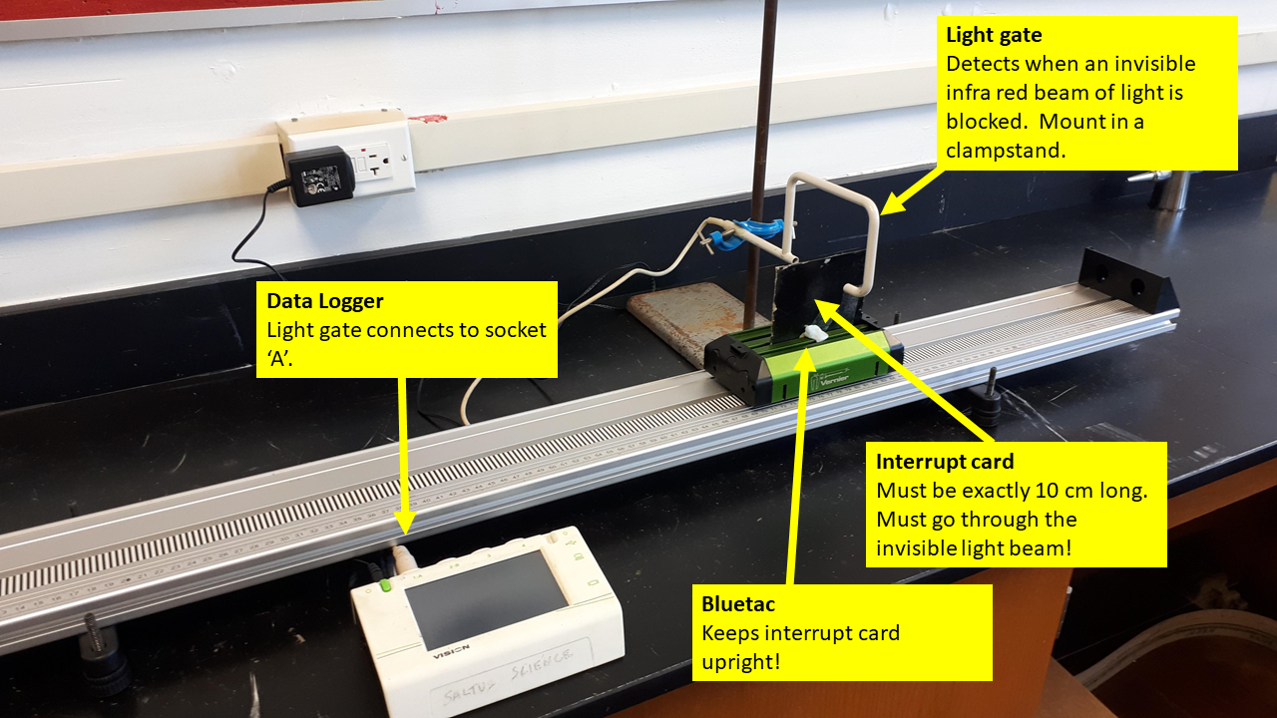

To set up the datalogger, follow the instructions below. These are from the PC version of the software, but the dataloggers are very similar. Use a tip of a pencil if the pointer is missing from your unit.

- Turn on the datalogger unit. You need to hold the button down for 5 seconds at least. You will see a dialogue box that looks like this. Select the TIMING option (has a clock icon).

- On the next dialogue box, select Speed/Velocity. Click next.

- Select ‘at A’ – assuming that the lightgate is plugged into socket A! Click next.

- Select ‘Single Interrupt Card’. Click next (with practice, you can skip to ‘Finish’)

- Here you can change the length of the interrupt card. The default is 100 mm, so it is easiest to ensure that the actual card in the experiment matches this. Sometimes we change this if we are measuring the speed of a different object, such as a ball bearing. Click next (note 100 mm = 10 cm = 0.1 m)

- It is nice to see both the speed and the time used to calculate it. Leave both of these as the defaults. The little fairy inside the box uses the equation:
$$v=\frac{x}{t}$$
to calculate the speed, where $x$ = length of the card and $t$= time that the light beam was interrupted. Here you can choose the level of accuracy of the data. Click next

- Select time as well as speed. Click FINISH

- To run the datalogger, click the green play button. Try to avoid touching the bar chart on the screen from now on as it will select data and confuse the situation!
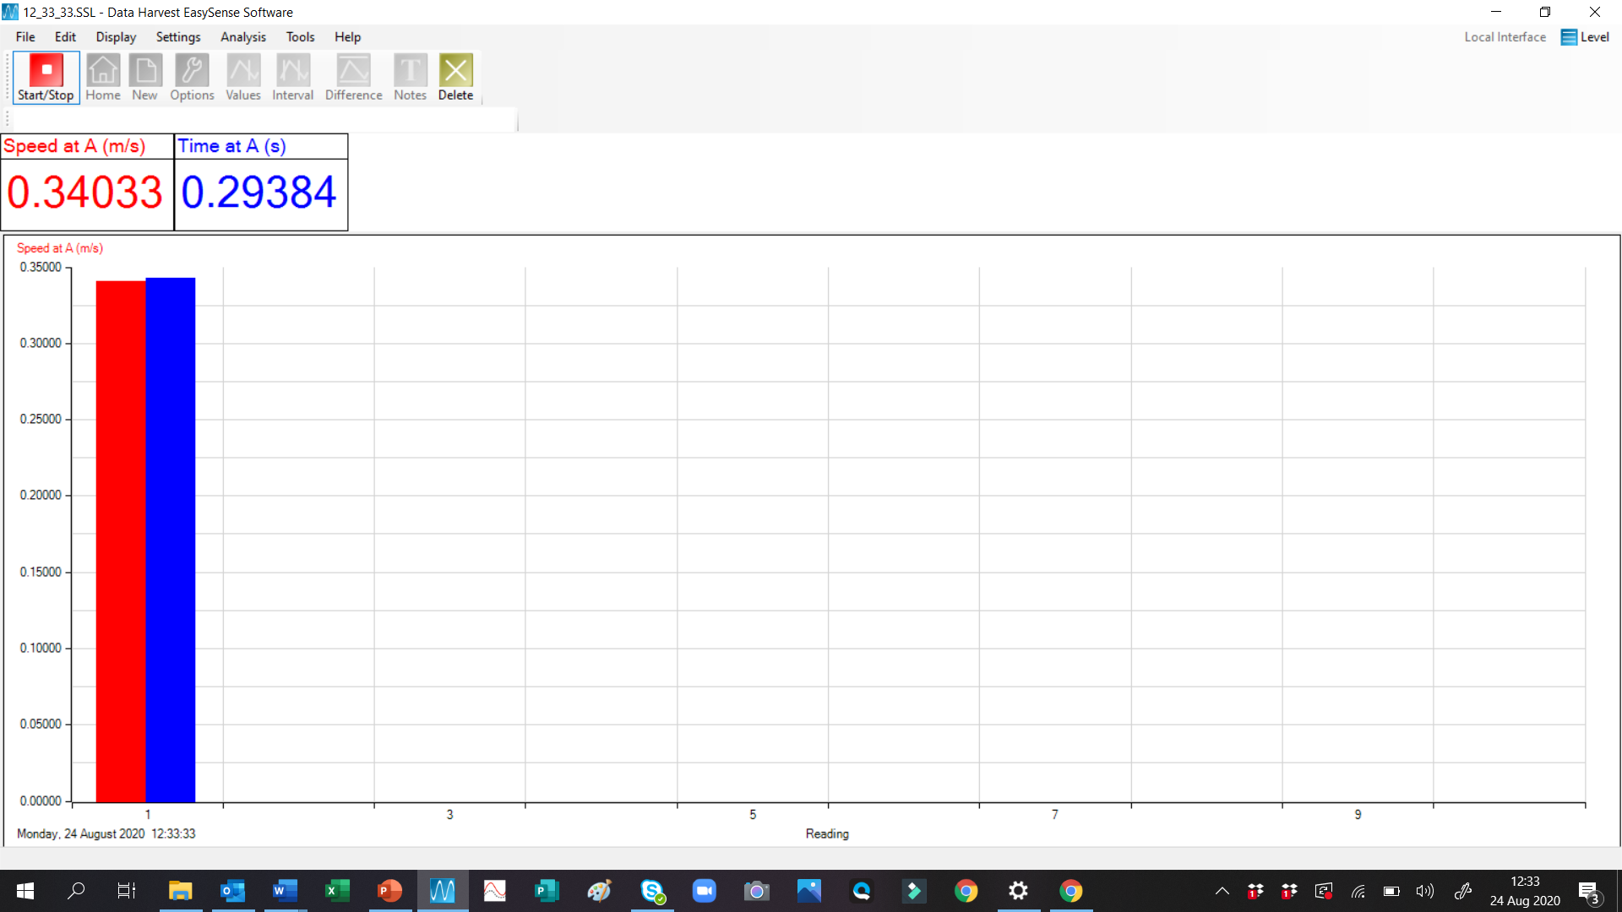
Speed = 0.34 m/s
Time of interrupt card breaking the beam = 0.29 sec
$$v=\frac{x}{t}$$
$$v=\frac{0.1}{0.29}$$
$$v=0.34\text{m}\text{/}\text{s}$$
Ignore bar chart

Experiment 1 – Measuring Speed

Put a book under one end of the track so that the cart gains speed as it rolls down it. You are going to measure the speed of the cart near the bottom. It is good practice to repeat an experiment three times to ensure consistency and reliability. Be sure to start the cart at the same location each time. Don’t move the light gate!

Trial | Time interval  (s) | Speed  (m/s)
1
2
3

Average speed at the bottom of the track = ……………………………………….. m/s (4 marks)

Experiment 2 - Measuring Acceleration 1

As an object gains speed we say that it has accelerated. You are going to measure this using two methods.

Acceleration is the rate of change of velocity. It is calculated using the following equation:
$$a=\frac{\left(v-v_{0}\right)}{t}$$
So, we need to measure the speed at two points and the time interval between them. This can be achieved by setting up two lightgates.
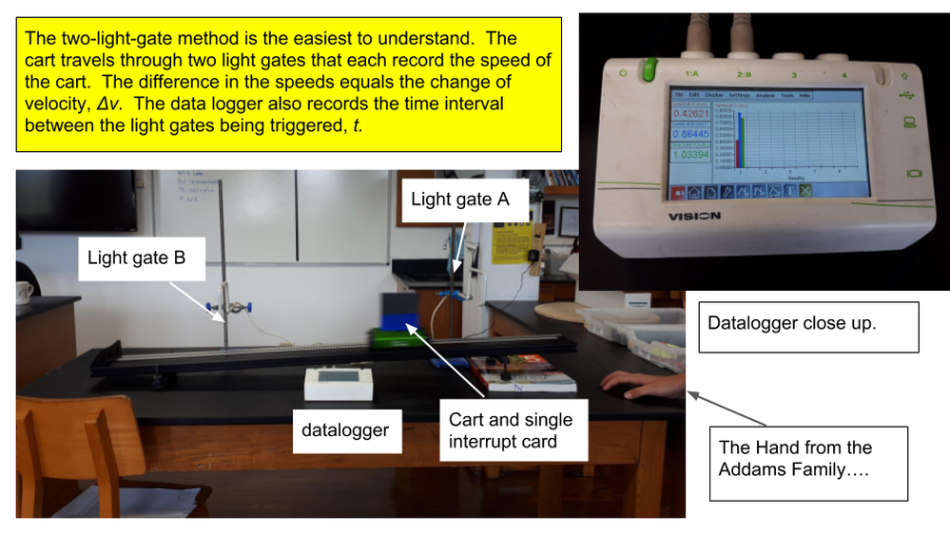

You will need to return to the home page of the datalogger – house icon. The main difference in the set up for the datalogger is to set the timing from A and then B. See below:

Two things are very important:
- You have lightgate A at the top of the slope and lightgate B at the bottom.
- You do not run the cart back up the slope! The system needs lightgate A to be triggered first. This is the most common source of frustration with the data!

Data Table

Trial | Initial velocity (m/s) | Final velocity (m/s) | Time interval  (s) | Acceleration (m/s²)
1
2
3

Mean acceleration = ………………………………………………. m/s² (4 marks)

Measuring Acceleration – Method 2
The other method of measuring the acceleration does not need the time interval to be recorded. You can measure the distance between the light beams and use the equation:

$$v^{2}=v_{0}^{2}+2ax$$

Rearrange to give:
$$a=\frac{\left(v^{2}-v_{0}^{2}\right)}{2x}$$

If the slope and the lightgates are in the same places for both methods, you should get the same answer!

Data Table

Trial | Initial velocity (m/s) | Final velocity (m/s) | Distance  (m) | Acceleration (m/s²)
1
2
3

Mean acceleration = ………………………………………………. m/s² (4 marks)

Evaluation: Discuss the methods and your results in the space below. How consistent were they? How easy was it to do the experiment? How accurate do you think the experiment was?

(3 marks)

Total 15 marks

BONUS – if you have an accelerometer app on your phone, you could put your phone on the trolley and try to measure it that way. The units will probably be g, so multiply your result by 9.81 to get it into m/s². You may need to slo-mo video the screen using a second phone.

