Assignment 3 – Kinematics in 2-D Name MARK SCHEME

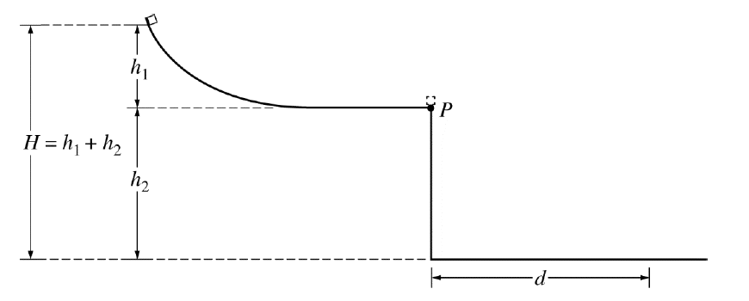
- A student releases a block from rest at the top of a slide of height, h₁. The block slides down the frictionless slide and off the end at point P, which is at a height, h₂, from the floor. The block hits the floor at a distance, d, from the end of the table. The overall height, H, is determined by the height of the lab ceiling and is fixed. The heights of the table and the slide are variable but must add up to the overall height H.

- Familiarize yourself with the experiment and sketch in the path of the block as it leaves the slide. Air resistance and friction are negligible. (1)

Sketched in a parabola
- Explain, without using any equations, why making the slide height, h₁, short would cause the range, d, to be small even though the height of the table, h_{2,} would be large. (3)

As the ramp height would be short, the block would not have gained much speed as it left the table. So even though its time-of-flight is longer, its horizontal velocity is not enough to give it a long range. It would flop more than soar.

- Explain, without using any equations, why making the table height, h₂, short would cause the range, d, to be small even though the height of the slide, h_{1,} would be large. (3)

As the ramp height would be long, the block would have gained a lot speed as it left the table. But as it is closer to the ground, its time-of-flight is much short, its large horizontal velocity is not enough to give it a long range as it is not in the air long enough to cover much distance.

- A Barcelona football player kicks a ball at a goal that is 32 m away as shown above. The ball is initially at rest and it leaves the player's foot at 20 m/s at an angle of 54° above the horizontal. Ignore the height of the goal (for now).

- Calculate the horizontal and vertical components of the initial velocity of the ball. (2)

$$v_{x}=v\cos{θ}=20\cos{54}=11.76 \text{m}\text{/}\text{s}$$

$$v_{y}=v\sin{θ}=20\sin{54}=16.18 \text{m}\text{/}\text{s}$$

- Determine the time it takes for the ball to reach the plane of the goal. (3)

$$v_{x}=\frac{x}{t}$$

$$t=\frac{x}{v_{x}}$$

$$t=\frac{32}{11.76}=2.72 \text{s}$$

- Will the ball reach the goal? If not, does it fall short or pass over the goal? (3)

Consider the vertical motion
$$x=v_{0}t+\frac{1}{2}at^{2}$$

$$y = (16.18×2.72) + (\frac{1}{2}×-9.81×{\left(2.72\right)}^{2})$$

$$y=44.0-36.29=7.7 \text{m}$$

The ball passes over the goal – bad luck Julian.

- Assuming that the angle that the ball is kicked at is constant, does he need to kick the ball harder or softer to score? Explain. (2)

Needs to kick the ball slightly softer to reduce its overall velocity

- How would factoring in the vertical height of the net affect the speed and/or angle that the footballer needs to score a goal? (2)

If the net in this case were 8 m high, he would have scored! In effect, the height of the net
widens the range of velocities and angles that are required to achieve the goal.

- Projectile motion is not just about cannonballs and footballs. It also works for jets of water. At home, produce a jet of water that forms a parabolic arc. The easiest way is to produce a horizontal jet. Methods could include: poke a hole in an empty soda bottle near the bottom, fill with water and set on a wall. You could have a family member hold a garden hose pipe steady. Measure the height of jet above the ground and the distance the jet goes. Take a photo and include it in your report. From this data, calculate the speed of the water from the jet as it leaves either the bottle or the hose pipe.

If you want an extra challenge, angle the hose upwards, measure the angle and repeat the calculation. You should get the same result. (Note: over a distance the air drag can affect the speed of the droplets – ignore this)

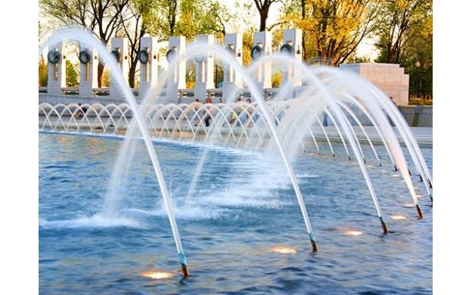

Any suitable calculation that leads to the speed of the jet of water! (6 marks)

